Spectral coherence: NZDUSD and USDJPY
Method 21 / daily log returns / Welch magnitude-squared coherence / Alpari D1 full available history

Study setup
Logical pair: NZDUSD , USDJPY
Broker symbols: NZDUSD_i , USDJPY_i
Snapshot: 2026-11-03_majors_alpari_D1
Timeframe: D1
Matched return window: 1999-01-05 to 2026-11-02 (UTC bar dates)
Matched return count n: 7185
Dropped unfinished last bar dated 2026-11-03 UTC after a tick-volume check against the prior complete day.
Welch: fs=1.0, nperseg=256, noverlap=128, window=hann, detrend=constant
Headline: gamma^2 nearest f=1/5; also 1/21 and 1/63
Complete matched rows (Excel): NZDUSD-USDJPY_Spectral_D1.xlsx
Complete matched rows (HTML table): NZDUSD-USDJPY_Spectral_D1_data.html

Method carried forward
Magnitude-squared spectral coherence gamma^2(f) measures shared linear power between matched daily log returns of close, ln(close_t / close_t-1), at each frequency f (cycles per day). Quotes are not inverted. Welch settings are frozen: fs=1, nperseg=256, noverlap=128, window=hann, detrend=constant. Headline is gamma^2 at the frequency bin nearest f=1/5 (five-day cycle from the formula sheet). Also reported: gamma^2 nearest f=1/21 and f=1/63, mean gamma^2 over the frequency grid, and phase of the cross-spectrum at the 1/5 bin. Coherence is unsigned (0 to 1); phase carries timing. Same-sample Pearson r is a side check only. This is not causation and not a trading signal.

Results (headline)
gamma^2 near 1/5: 0.118937
bin f (1/5): 0.199219
phase at 1/5 (rad): 2.506322
gamma^2 near 1/21: 0.066912
gamma^2 near 1/63: 0.037278
mean gamma^2: 0.045845
Pearson r: -0.133568

Target-frequency summary
period | target_f | f_bin | gamma2 | phase_rad
5 | 0.2 | 0.19921875 | 0.11893664 | 2.5063217
21 | 0.04761905 | 0.046875 | 0.06691196 | -3.1298205
63 | 0.01587302 | 0.015625 | 0.03727825 | -2.7935231

Conclusion
Headline gamma^2 near f=1/5 for NZDUSD and USDJPY: 0.1189 (bin f=0.199219, phase=2.5063 rad). At ~1/21: 0.0669; at ~1/63: 0.0373. Mean gamma^2 = 0.0458. Pearson r = -0.1336. This is frequency-domain linkage, not a trading signal.

Charts
Daily closes

Daily log returns

Spectral coherence gamma^2(f)
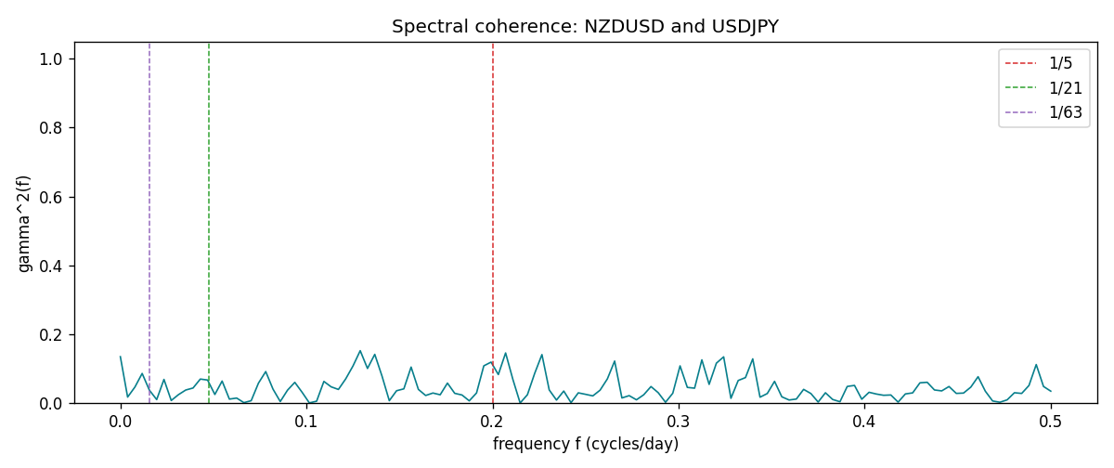

Data report
Matched rows and the coherence sheet are in the sibling Excel workbook named NZDUSD-USDJPY_Spectral_D1.xlsx. Embedding all rows as a Word table is impractical; this file holds column summaries and the first and last 15 matched rows.
Columns: time, NZDUSD_open, USDJPY_open, NZDUSD_high, USDJPY_high, NZDUSD_low, USDJPY_low, NZDUSD_close, USDJPY_close, NZDUSD_tick_volume, USDJPY_tick_volume, NZDUSD_spread, USDJPY_spread, NZDUSD_real_volume, USDJPY_real_volume, NZDUSD_log_return, USDJPY_log_return
Column summaries (matched calculation rows)
column | count | mean | std | min | 25% | 50% | 75% | max
NZDUSD_open | 7185 | 0.65641035 | 0.10820414 | 0.3913 | 0.59133 | 0.6684 | 0.72491 | 0.88218
USDJPY_open | 7185 | 113.80829 | 19.224285 | 75.693 | 104.39 | 110.98 | 120.695 | 163.824
NZDUSD_high | 7185 | 0.6603272 | 0.1086977 | 0.3961 | 0.59474 | 0.672 | 0.72936 | 0.88421
USDJPY_high | 7185 | 114.30556 | 19.28576 | 76.001 | 104.868 | 111.439 | 121.26 | 163.978
NZDUSD_low | 7185 | 0.65272421 | 0.10779902 | 0.3897 | 0.58806 | 0.66417 | 0.72098 | 0.87988
USDJPY_low | 7185 | 113.28523 | 19.152023 | 75.402 | 103.88 | 110.53 | 120.17 | 163.628
NZDUSD_close | 7185 | 0.65648647 | 0.10820164 | 0.3907 | 0.59157 | 0.6684 | 0.72502 | 0.8822
USDJPY_close | 7185 | 113.8211 | 19.239467 | 75.811 | 104.38 | 111.015 | 120.69 | 163.851
NZDUSD_tick_volume | 7185 | 68717.699 | 123140.61 | 16 | 5585 | 33899 | 58511 | 1127682
USDJPY_tick_volume | 7185 | 106344.18 | 179438.14 | 149 | 9948 | 53202 | 92889 | 1803508
NZDUSD_spread | 7185 | 30.280167 | 25.649381 | 0 | 9 | 17 | 40 | 80
USDJPY_spread | 7185 | 20.273626 | 17.623751 | 0 | 6 | 11 | 30 | 50
NZDUSD_real_volume | 7185 | 1.6703703e+10 | 8.4983725e+10 | 0 | 0 | 0 | 0 | 2.705649e+12
USDJPY_real_volume | 7185 | 3.4781051e+10 | 1.6093614e+11 | 0 | 0 | 0 | 0 | 3.8834203e+12
NZDUSD_log_return | 7185 | 1.284e-05 | 0.0076404 | -0.07027433 | -0.00425236 | 0.00022967 | 0.00458145 | 0.05966839
USDJPY_log_return | 7185 | 4.789e-05 | 0.00620418 | -0.03908203 | -0.00320044 | 0.00011802 | 0.00340223 | 0.05184024
First 15 matched rows (selected columns)
time | NZDUSD_log_return | USDJPY_log_return
1999-01-05 | -0.0018597736 | -0.00017868311
1999-01-06 | 0.0020455609 | 0.0075660159
1999-01-07 | 0.0062963171 | -0.012851583
1999-01-08 | -0.00055396548 | -0.0047719894
1999-01-11 | 0.010290425 | -0.016195423
1999-01-12 | -0.0053157489 | 0.032310364
1999-01-13 | -0.0099742238 | 0.0081373171
1999-01-14 | -0.00018564931 | 0
1999-01-15 | -0.00074294208 | 0.0055343401
1999-01-18 | -0.0018597736 | 8.7600193e-05
1999-01-19 | 0.0018597736 | -0.0056219403
1999-01-20 | 0.0040793678 | -0.0053879917
1999-01-21 | 0.0040627941 | 0.0084664056
1999-01-22 | -0.012051689 | 0.0060412564
1999-01-25 | -0.0035504102 | -0.0073594164
Last 15 matched rows (selected columns)
time | NZDUSD_log_return | USDJPY_log_return
2026-10-13 | 0.0047326165 | -0.0018932826
2026-10-14 | -0.0037306483 | 7.5800166e-05
2026-10-15 | 0.0047634855 | -0.0018524319
2026-10-16 | 0.0057501001 | -0.00037976126
2026-10-19 | 0.0018917133 | 0.0034946841
2026-10-20 | 0.0037199341 | -0.0022546642
2026-10-21 | 0.0030923331 | -0.00032883504
2026-10-22 | -0.0033035227 | -0.0085942669
2026-10-23 | 0.0030929853 | 0.00035080446
2026-10-26 | -0.0028993932 | 0.0041238746
2026-10-27 | -0.00026399852 | 0.0027651658
2026-10-28 | -0.0097283914 | -0.00095679538
2026-10-29 | 0.00062190714 | -0.00038043789
2026-10-30 | 0.00019537668 | -0.0010596481
2026-11-02 | -0.0025962955 | 0.0026438521
First 15 frequency bins
f | gamma2 | phase_rad | period_days
0 | 0.13468667 | 3.1415927 | inf
0.00390625 | 0.01737259 | -2.8520755 | 256
0.0078125 | 0.04643471 | -2.960683 | 128
0.01171875 | 0.08602654 | 2.8660311 | 85.333333
0.015625 | 0.03727825 | -2.7935231 | 64
0.01953125 | 0.0101063 | -2.4340082 | 51.2
0.0234375 | 0.06865176 | 3.0895477 | 42.666667
0.02734375 | 0.00741151 | -2.2387398 | 36.571429
0.03125 | 0.02452206 | -2.6753318 | 32
0.03515625 | 0.03791245 | -2.4987694 | 28.444444
0.0390625 | 0.04371945 | 2.7923852 | 25.6
0.04296875 | 0.06970269 | 2.8894351 | 23.272727
0.046875 | 0.06691196 | -3.1298205 | 21.333333
0.05078125 | 0.02495788 | -2.8192686 | 19.692308
0.0546875 | 0.06395062 | -2.9317448 | 18.285714

